Final Website

The Homepage:

The first view of the website has to be attractive for the user. It needs to be bright so that it catches his attention while also look modern and state of the art.

I decided to create an interactive navigation bar to achieve this. The buttons of the navigation bar highlight themselves when the user moves the mouse over them. At the beginning of the project I didn’t have this feature but later on I realised that it will add a lot of value to the website.

Another thing I implemented is the image carousel. When I began coding the website I only added an image as a background. I noticed that that looked too boring so I decided to add something interactive to the home page. I chose the image carousel because it lets me add different slides of information while also looking very sharp and modern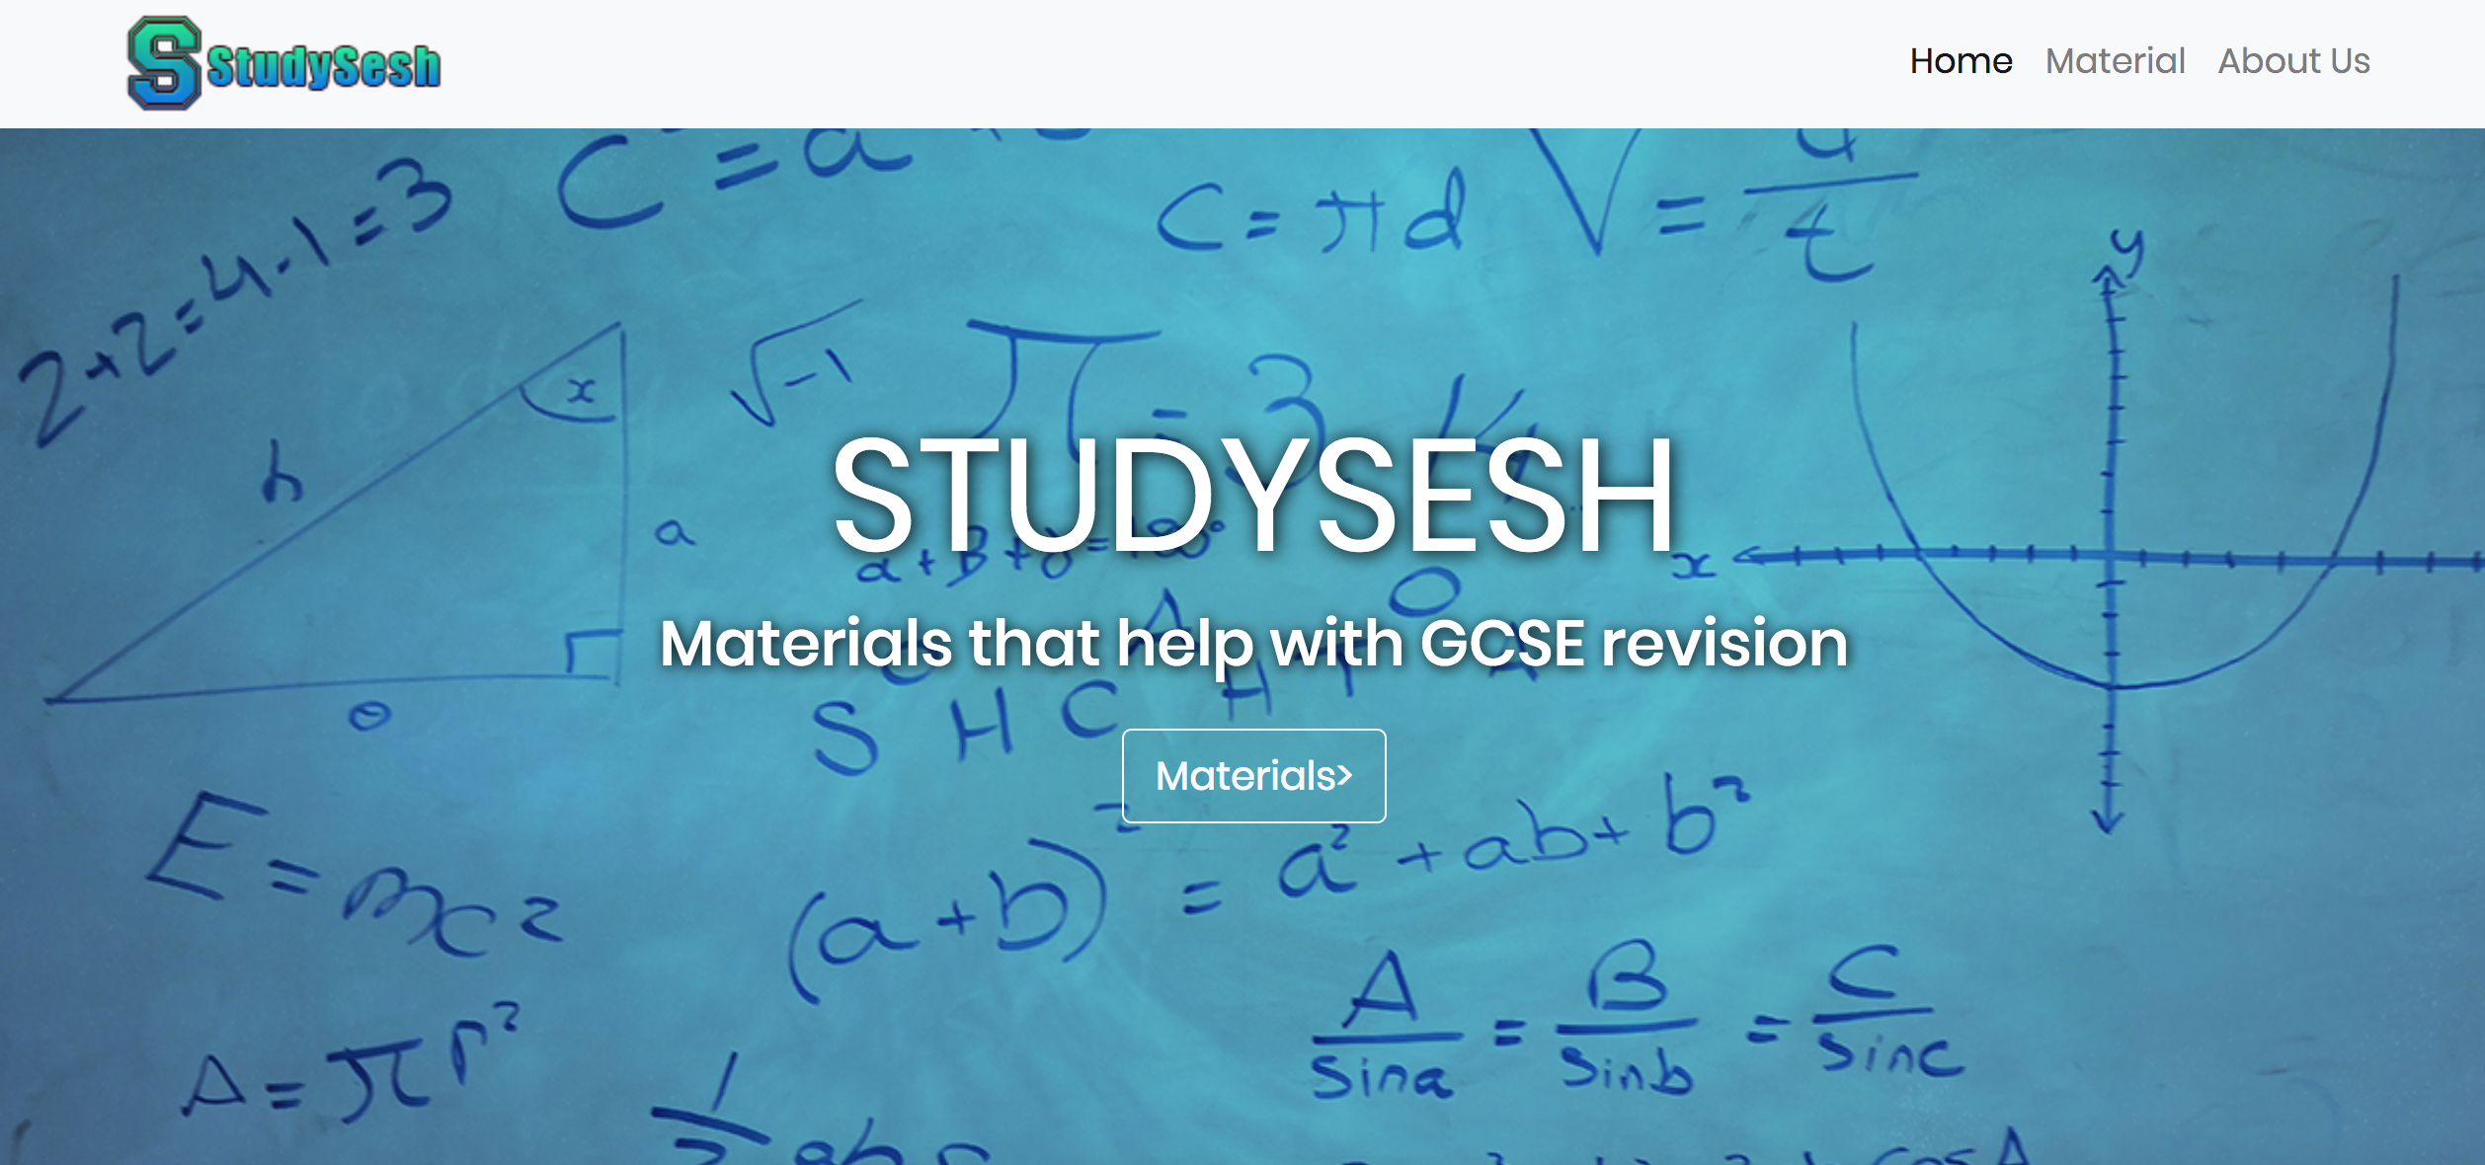

Another section that I added to the homepage is the Subject section where the user can see all the materials that the website offers. This design has been active since the beginning of the project as I think it suits the style of the website and it also adds a lot of useful information to the user.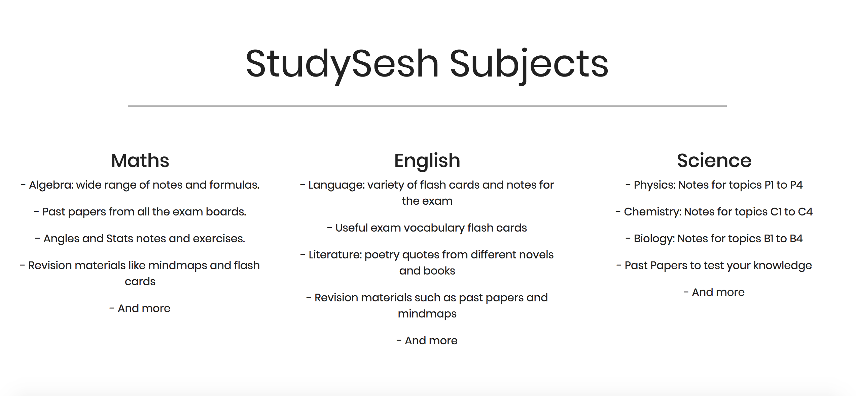

The footer can be found on every page of the website, as it doesn’t vary from page to page. The footer contains a connect section where users can see about StudySesh social media. This connect section would only be working when the website officially launches publicly as the social media pages are yet to be created.

The information at the bottom of the footer adds valuable information about the website and its creator, which adds credibility to the website

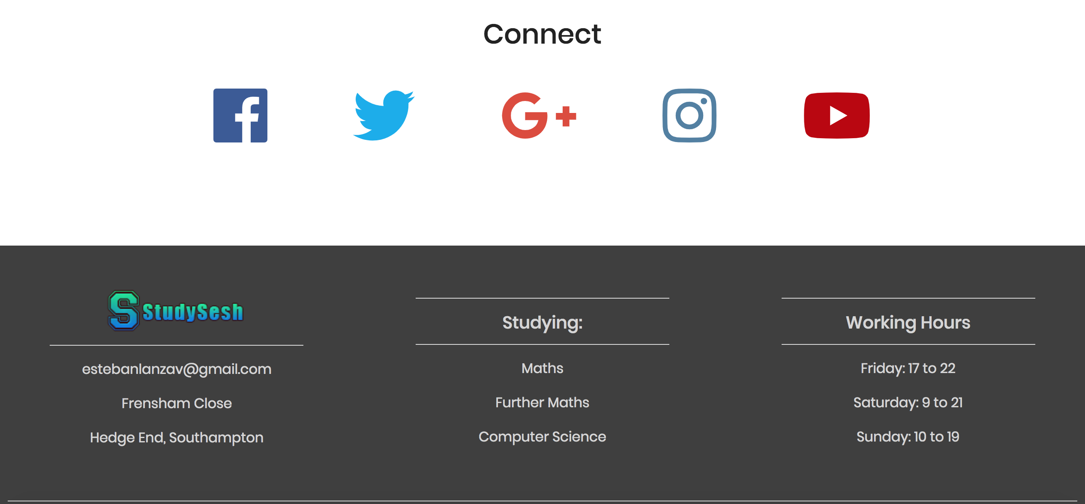

Materials page:

The main page of the materials page contains the links to the subject pages where the user may find the information he/she wants. I initially used logos that were copyrighted so I made some research and found out some logos that did not have any copyright restrictions, meaning that I could use them for free.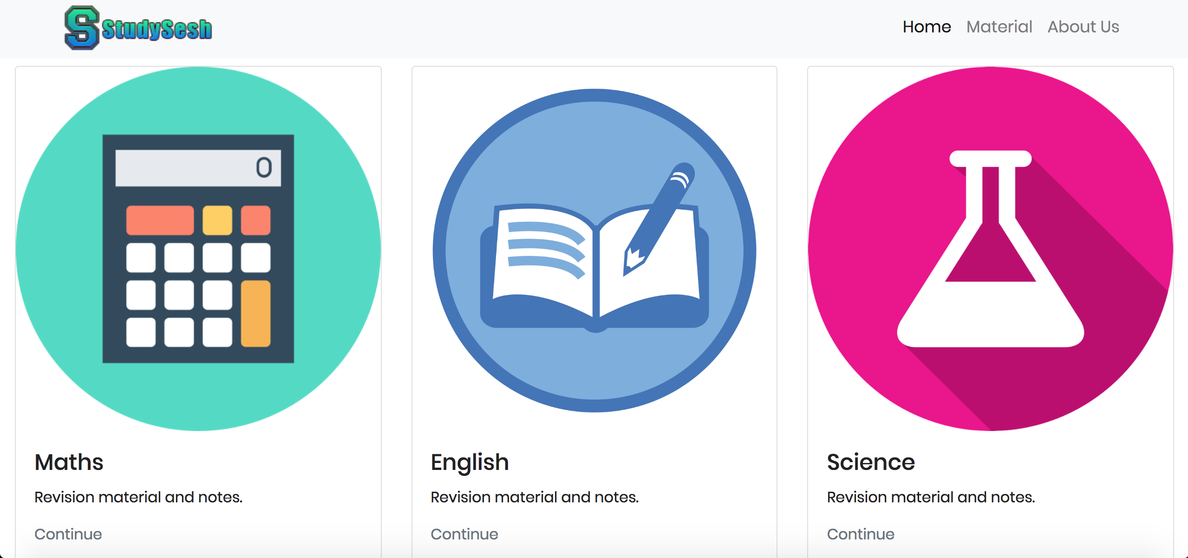

Maths page:

The maths page contains multiple links for the user to use. He will be able to click on the links and should be transferred to another website with relevant information about the topic the user was initially interested in.

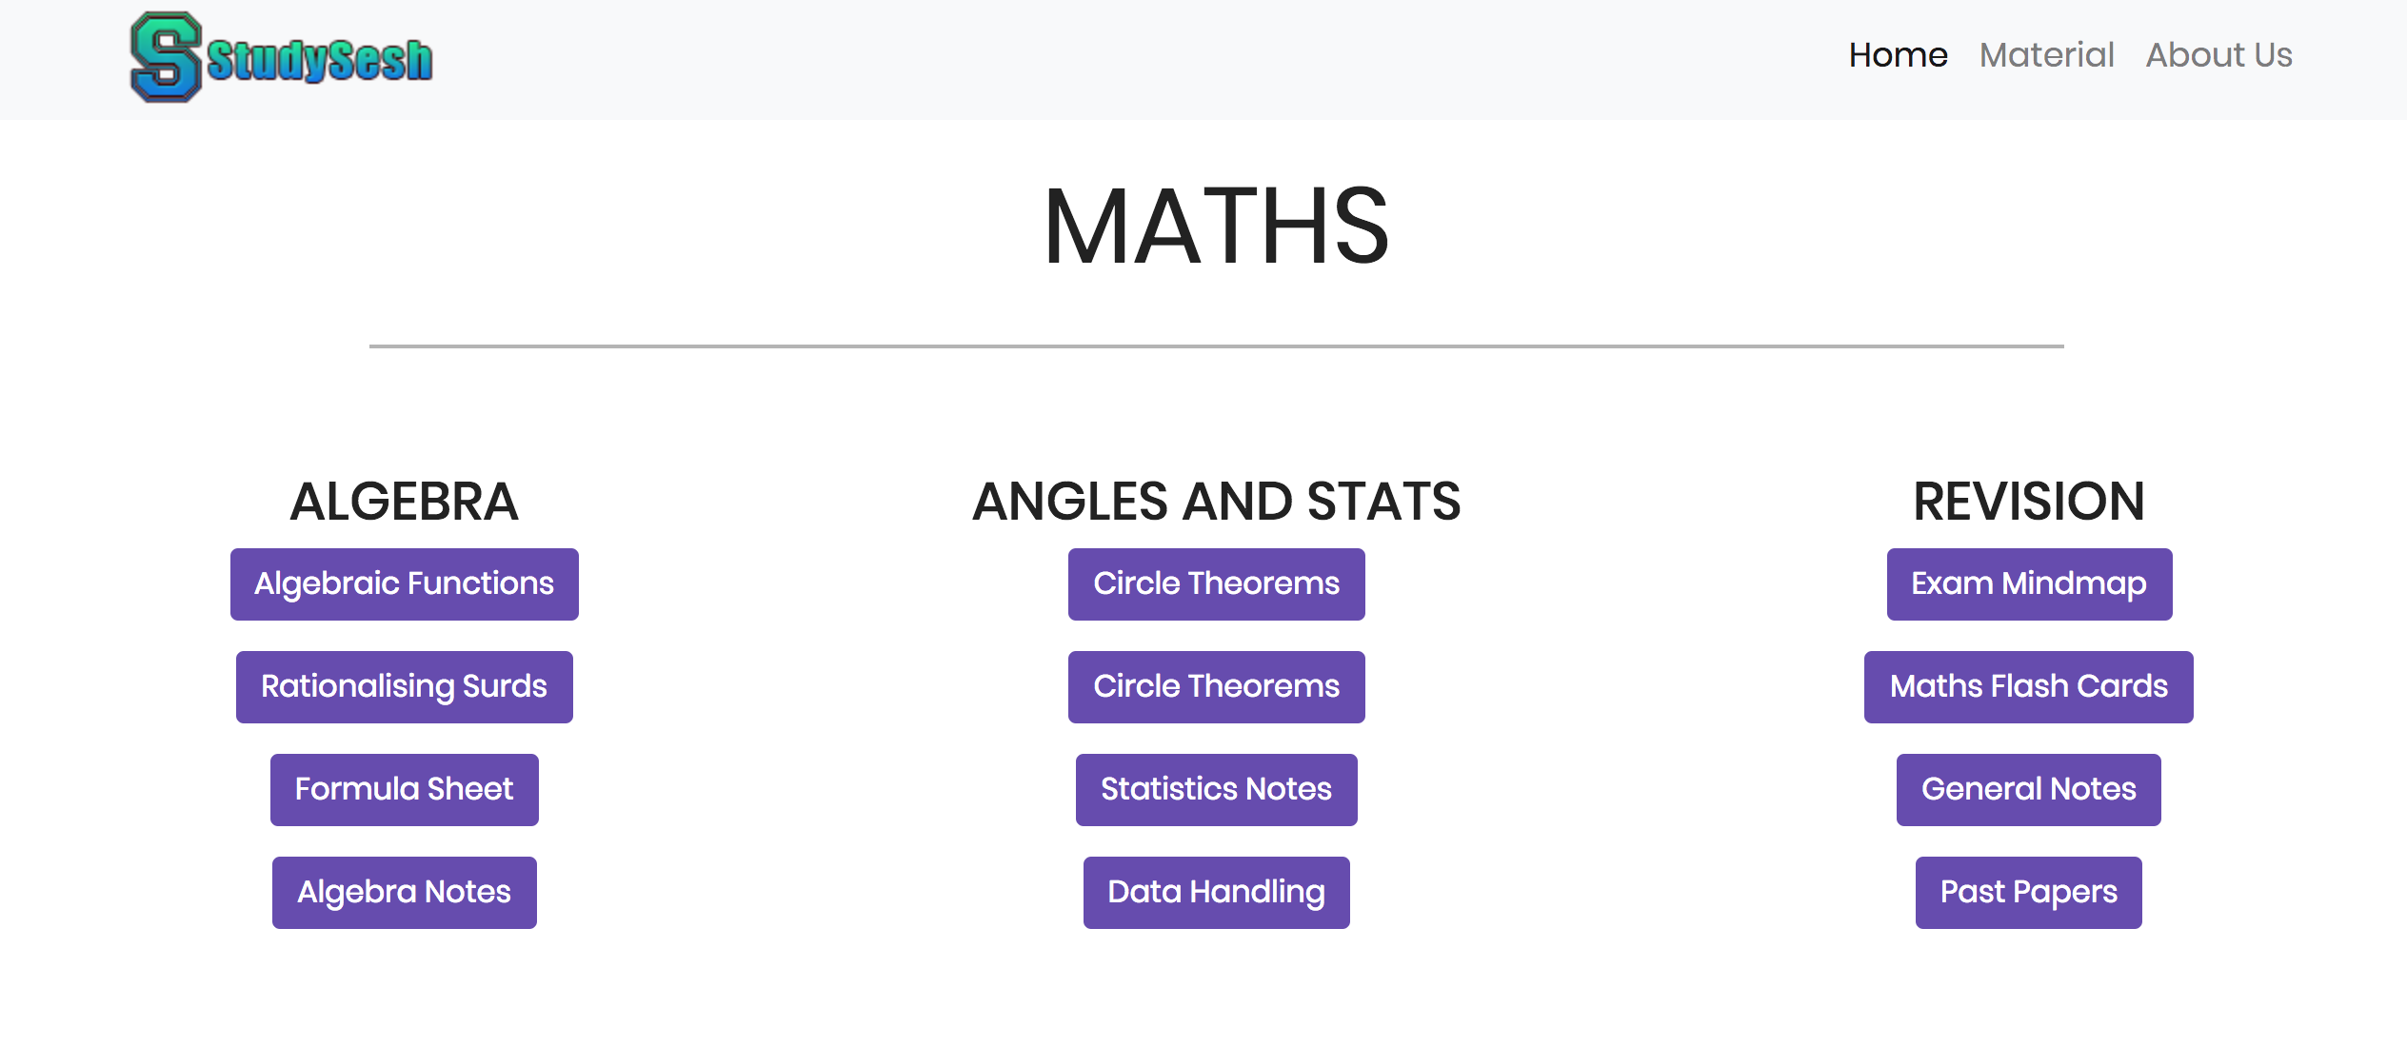

English page:

The English page contains multiple links for the user to use. He will be able to click on the links and should be transferred to another website with relevant information about the topic the user was initially interested in.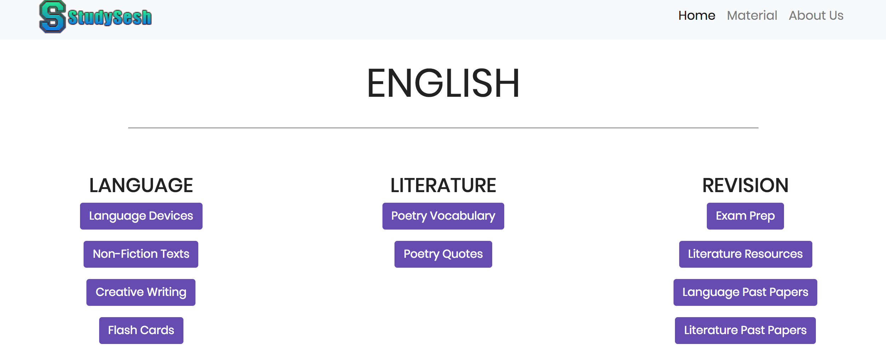

Science page:

The Science page contains multiple links for the user to use. He will be able to click on the links and should be transferred to another website with relevant information about the topic the user was initially interested in.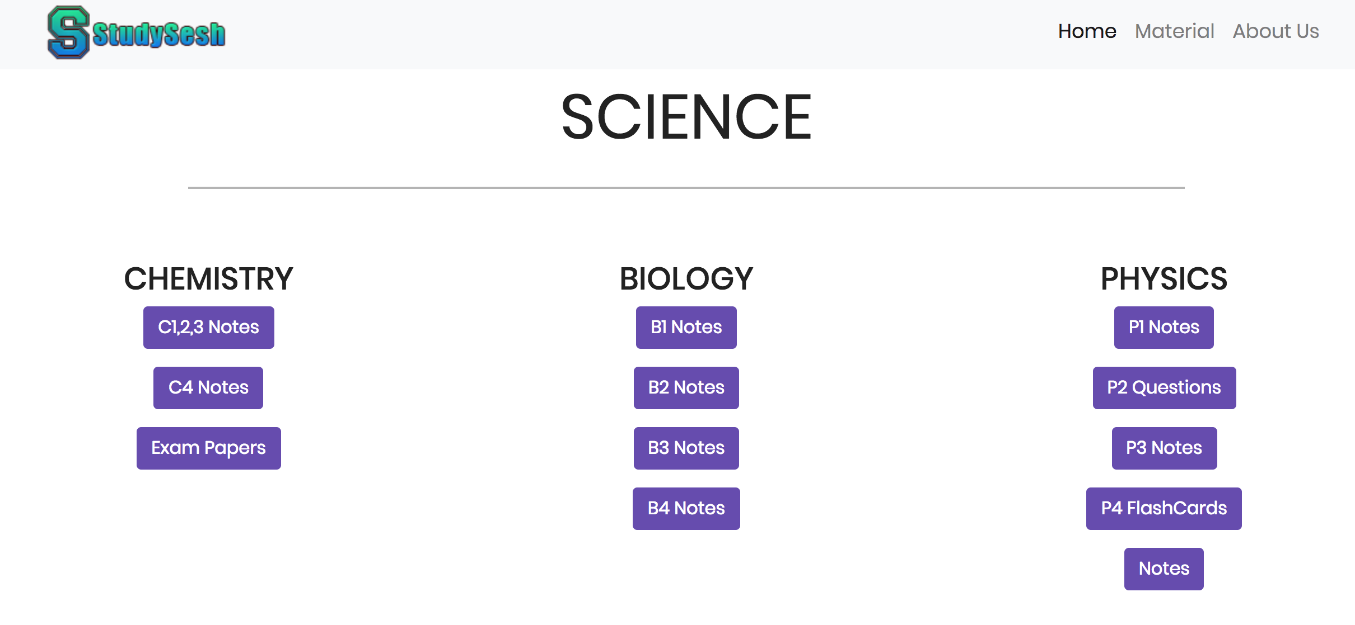

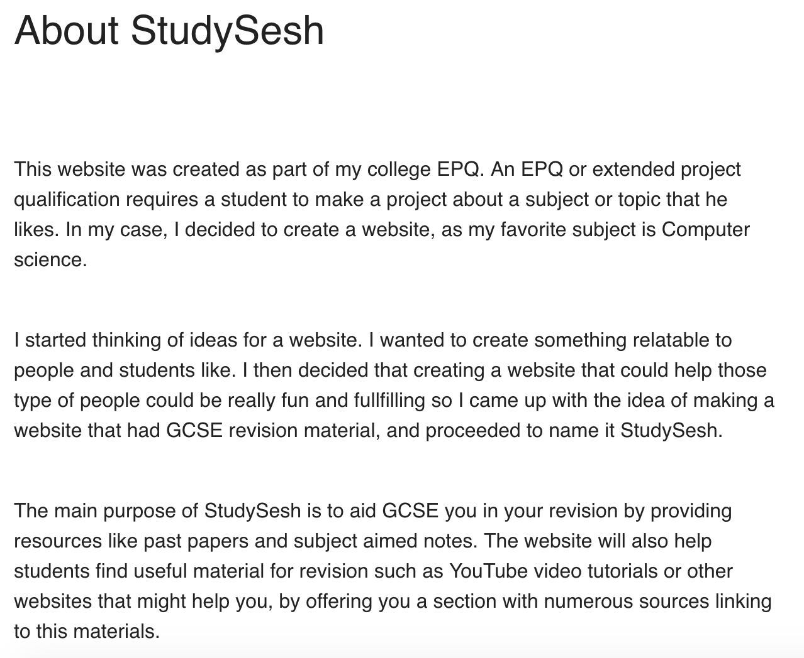

About Us page:

The about us page will contain a bit more information about the website an the initial ideas around it. I tried to make it as shorter as possible as my target audience doesn’t like big texts.

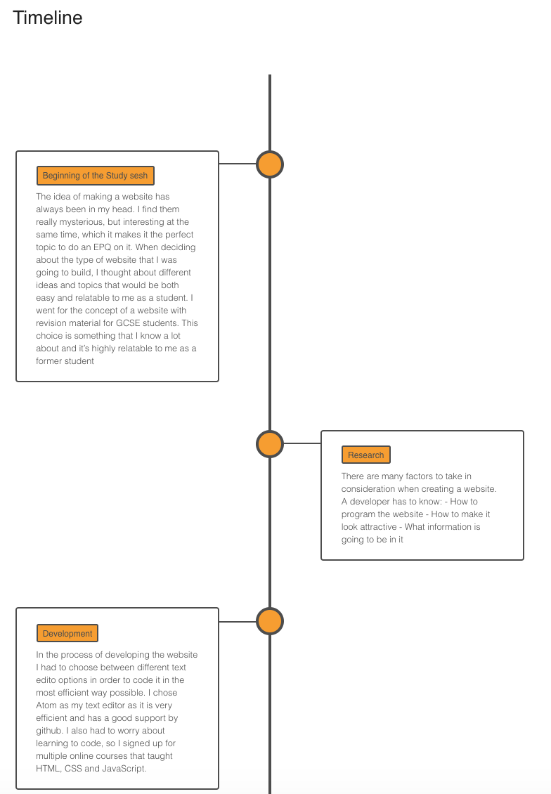

I initially though of the idea of explaining the creation of the website to the user, so I created a big chunk of text and displayed it on the website. I later found that it looked pretty boring so I decided to create a timeline to make it look more attractive

The timeline in the page, documents the process of the creation of the website. It explains 4 stages of the process in detail while also making it look modern and attractive for the user.